**Use Case Descriptions and Diagrams**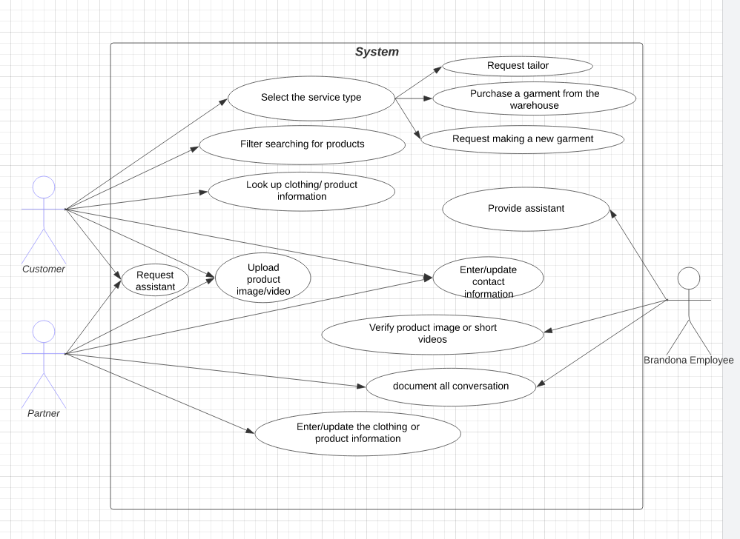 The use case diagram illustrates the interactions between three actors: CUSTOMER, PARTNER, and EMPLOYEE.

CUSTOMER and PARTNER share three use cases: requesting assistance, uploading product images/videos, and entering/updating contact information. When a CUSTOMER or PARTNER requests assistance, the EMPLOYEE responds by providing support through a corresponding use case.

Both CUSTOMER and PARTNER can upload product images or videos, but the PARTNER can also include or update product information with these uploads. While the PARTNER uploads images/videos to showcase their products, the CUSTOMER can upload images/videos as reviews for purchased products, showcasing a similar capability for different purposes.

The CUSTOMER has additional use cases, such as browsing products and services and requesting three different types of services, which are outlined in the diagram.

When images/videos are uploaded by a CUSTOMER or PARTNER, an EMPLOYEE is responsible for reviewing the content to ensure it meets the platform's standards.

Finally, both PARTNER and EMPLOYEE are tasked with recording and documenting their interactions with the CUSTOMER, ensuring proper tracking and accountability.

**Workflow Diagrams**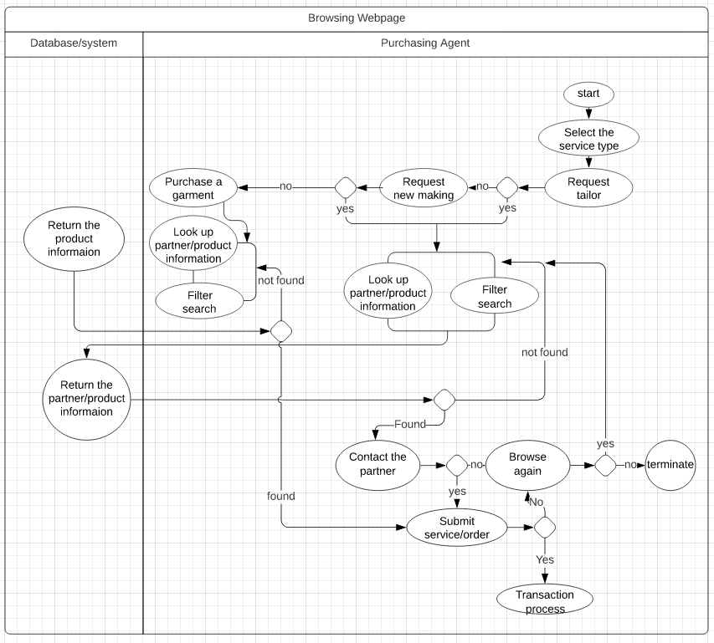

The workflow diagram outlines how the customer interacts with the system, guiding them through the process from selecting a service to completing a transaction. The workflow begins by prompting the customer to choose a service. At each step, the system evaluates their input with a yes/no condition to determine the next step.

* **Tailoring and Seamstress Services:** These options involve one-to-one interactions between the customer and an active partner. The workflow focuses on connecting the customer with a skilled individual who can meet their specific needs. Customers can browse partner portfolios to view their work, skills, and specialties, helping them make an informed decision. If a suitable partner is found, the customer can request their service, or they may choose to browse further.
* **Buying Garments:** This option mirrors typical e-commerce interactions. Customers can browse garments by using the search bar or filtering available options. Once they find an item of interest, they are directed to decide whether to purchase it. If not, they can return to browsing.
* **Tailoring or Making New Garments:** This process differs from browsing products, as the focus shifts to finding a professional tailor or seamstress. Customers can communicate directly with potential partners to ensure their needs are met. The browsing experience here emphasizes evaluating the partner's expertise rather than browsing for products.

The workflow ensures that customers are guided effectively based on their chosen service, whether they are exploring garments for purchase or selecting a professional partner for custom tailoring or garment creation.

**Screen Layout**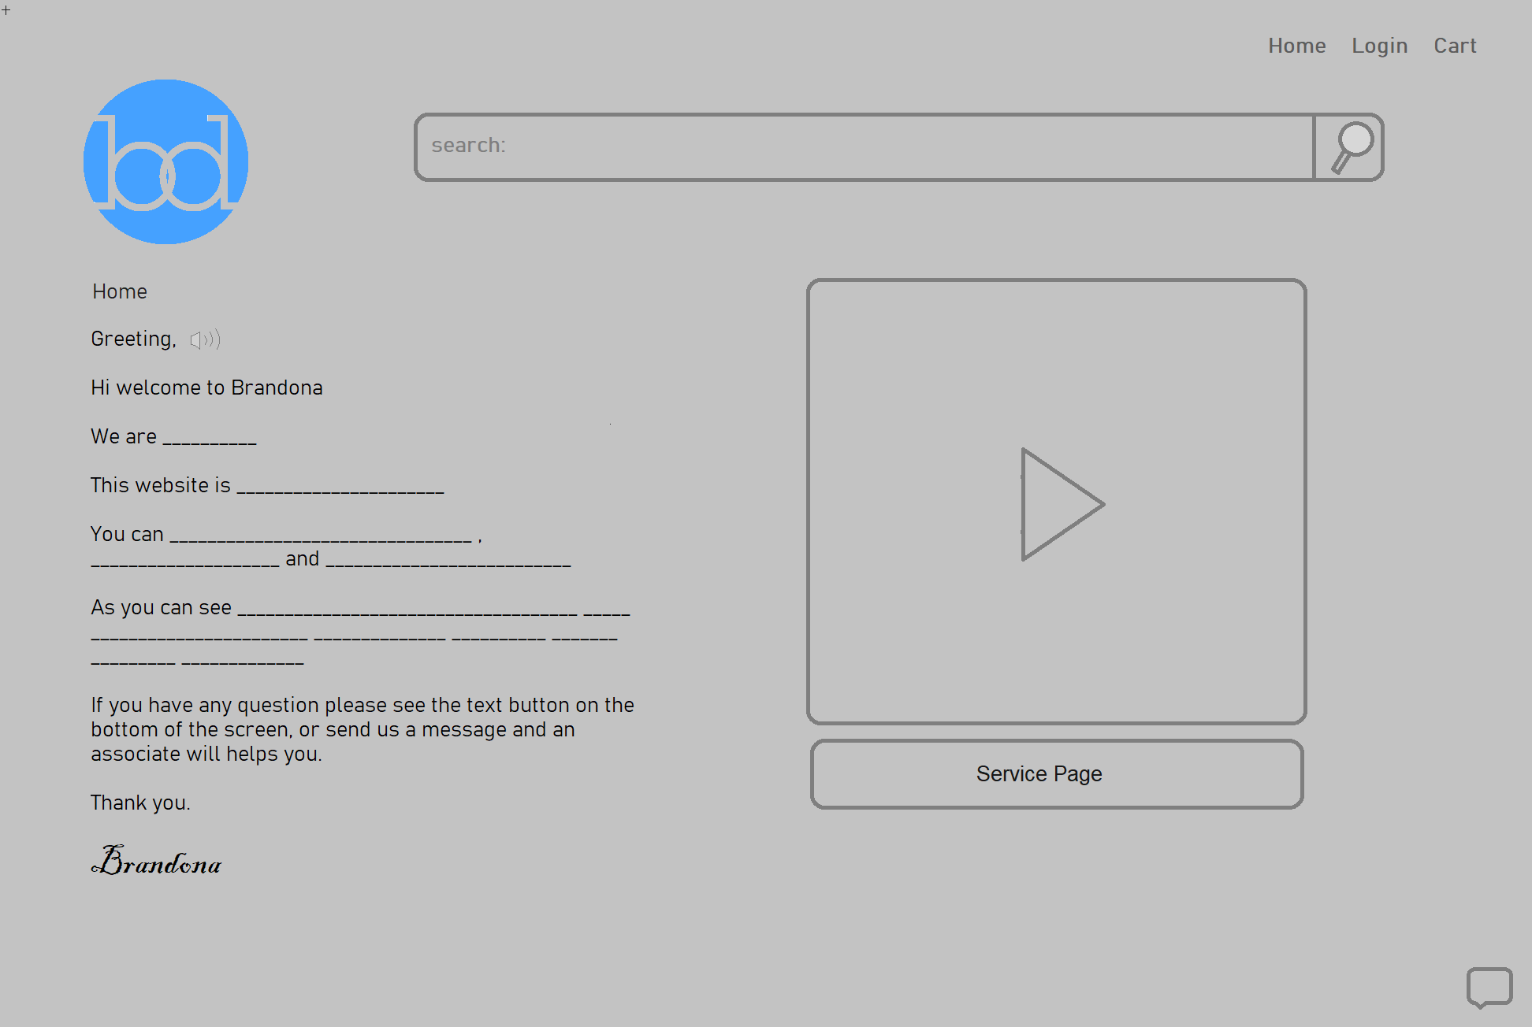

The image above showcases the layout of the website's home page. It features a concise introduction that informs customers about the website's purpose and the services it offers. The page includes a brief description of its structure to help users navigate easily. Additionally, there is an embedded short video that provides a quick overview, enhancing the customer's understanding and engagement with the site.

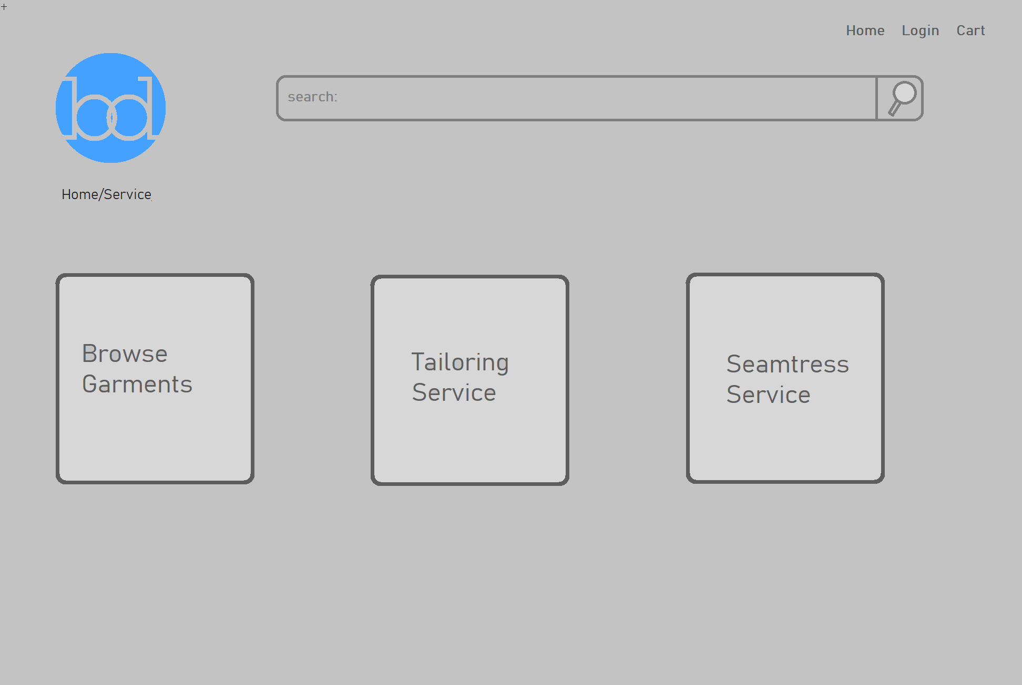 The image above highlights the three types of services offered by the website. Users can choose from these options to find the service that best suits their needs.

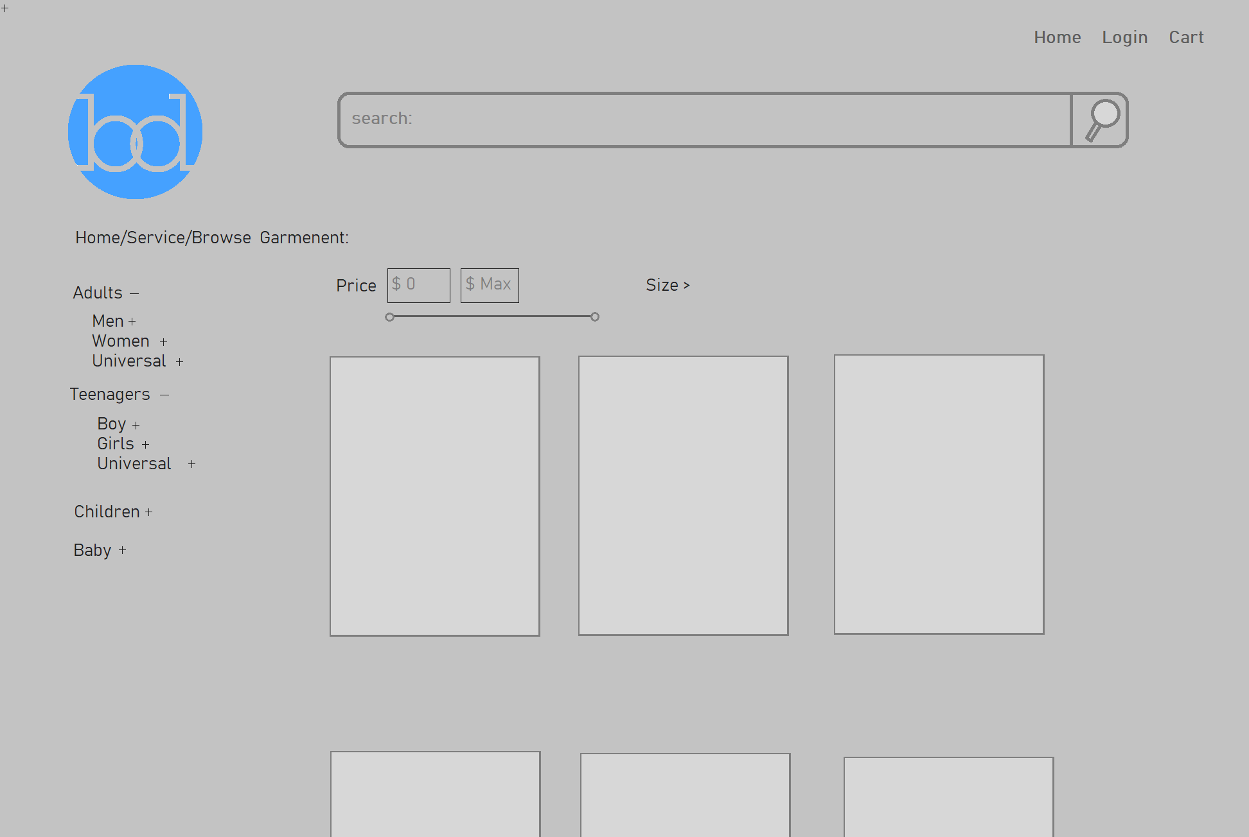

The image above displays the "Browse Garment" page, where users can explore a variety of garments. The page includes options to filter by price and other criteria, along with a search bar to help users refine their choices and find specific items more easily.

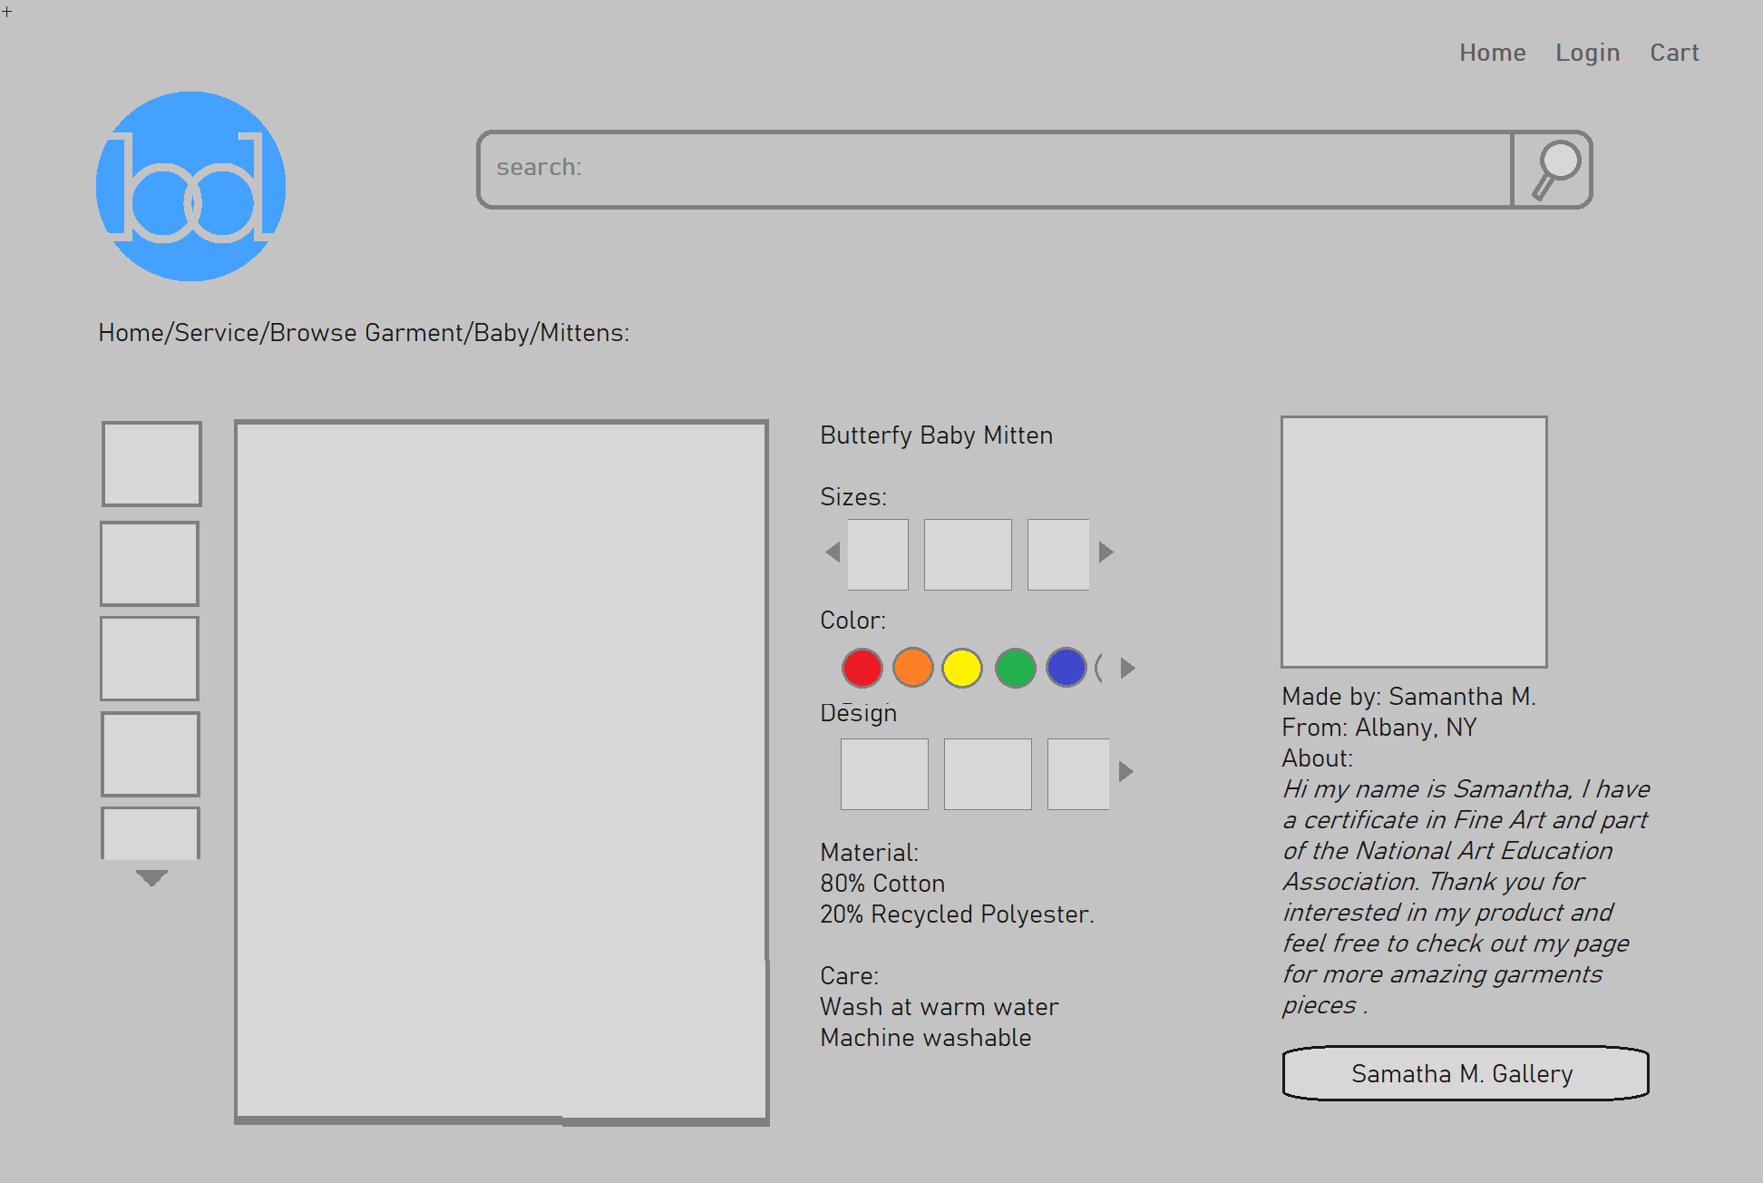

The product page provides detailed information about each item, including images or videos showcasing the garment. It also includes additional details about the garment's creation, offering users a comprehensive view of the product.